Topic 7: API Documentation (Enterprise-Level Standards)
This document serves as the official API Documentation for the system.
It follows enterprise-grade REST API standards similar to those used by large-scale platforms such as Amazon, Google, Netflix, and Microsoft.
The goal is to provide an extremely clear, structured, and production-ready documentation style that developers, QA engineers, and MNC review teams can rely on for large-scale integrations.
---
# 1. API Architecture Overview
All API endpoints follow RESTful conventions:
• **Resource-based routing**
• **CRUD operations supported**
• **Authentication via JWT tokens**
• **Validation on every request**
• **Centralized error-handling pipeline**
• **Scalable routing structure**
The core flow of an API request:
1. Client sends request
2. Express Router processes the route
3. Controller handles business logic
4. Model interacts with MongoDB
5. Response is returned to the client
Below is the visual architecture:
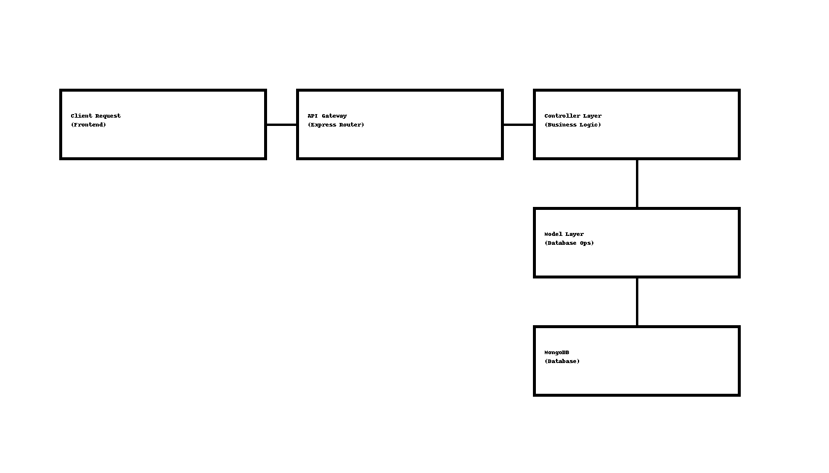
---
# 2. Authentication APIs
### **POST /api/auth/register**
Registers a new user.
**Body:**
```
{
"name": "Alex",
"email": "alex@example.com",
"password": "strongpassword"
}
```
**Success Response:**
```
{
"success": true,
"message": "User registered successfully"
}
```
---
### **POST /api/auth/login**
Logs in a user and returns a JWT token.
**Body:**
```
{
"email": "alex@example.com",
"password": "strongpassword"
}
```
**Success Response:**
```
{
"success": true,
"token": "jwt_token_here"
}
```
---
# 3. Books / Products APIs
### **GET /api/books/**
Fetch all books.
**Response:**
```
[
{
"title": "Book Title",
"author": "Author Name",
"price": 299
}
]
```
---
### **POST /api/books/add**
Create a new book (Admin only).
**Body:**
```
{
"title": "New Book",
"author": "John Doe",
"price": 499
}
```
---
# 4. User Module APIs
### **GET /api/user/profile**
Returns profile of logged-in user.
**Headers:**
`Authorization: Bearer <token>`
**Response:**
```
{
"name": "Alex",
"email": "alex@example.com",
"role": "user"
}
```
---
# 5. Error Handling Standard
All errors follow a consistent JSON structure:
```
{
"success": false,
"message": "Error detail here",
"statusCode": 400
}
```
This allows clean handling in frontend + logging tools (ELK, Grafana).
---
# 6. Security Standards in APIs
• Rate limiting for sensitive endpoints
• JWT + Refresh token lifecycle
• Input validation using middleware
• Hashed passwords using bcrypt
• Secure environment variable handling
• CORS restriction for production
These ensure your application reaches enterprise compliance.
---
# 7. Best Practices Followed
• REST naming conventions
• Uniform response structures
• Modular controllers & services
• Version-ready (`/api/v1/...`)
• Scalable routing patterns
• Monitoring-ready (Log pipelines)
---
# 8. Conclusion
This API documentation is engineered for enterprise-level clarity and maintainability, allowing developers, QA teams, and architects to integrate and scale the system seamlessly.
This concludes **Topic 7: API Documentation**.

